Design and implement a robust, distributed system using C++ that effectively leverages signals, sockets, and inter-process communication (IPC) to manage and coordinate multiple processes for a real-time data processing pipeline.

System Requirements

Data Ingestion: Continuously receive data from multiple sources (e.g., network sockets, files, sensors) and distribute it across multiple worker processes.

Data Processing: Distribute incoming data to multiple worker processes, each responsible for specific data transformations or calculations.

Error Handling: Implement robust error handling mechanisms using signals to gracefully handle unexpected events (e.g., process termination, network failures).

Inter-Process Communication: Utilize IPC (e.g., shared memory, message queues) for efficient communication and synchronization between processes.

Performance Optimization: Optimize the system for low latency and high throughput, considering factors like network congestion, process scheduling, and data transfer efficiency.

Scalability: Design the system to handle increasing data volumes and processing load by dynamically adjusting the number of worker processes.

**Server CODE :**

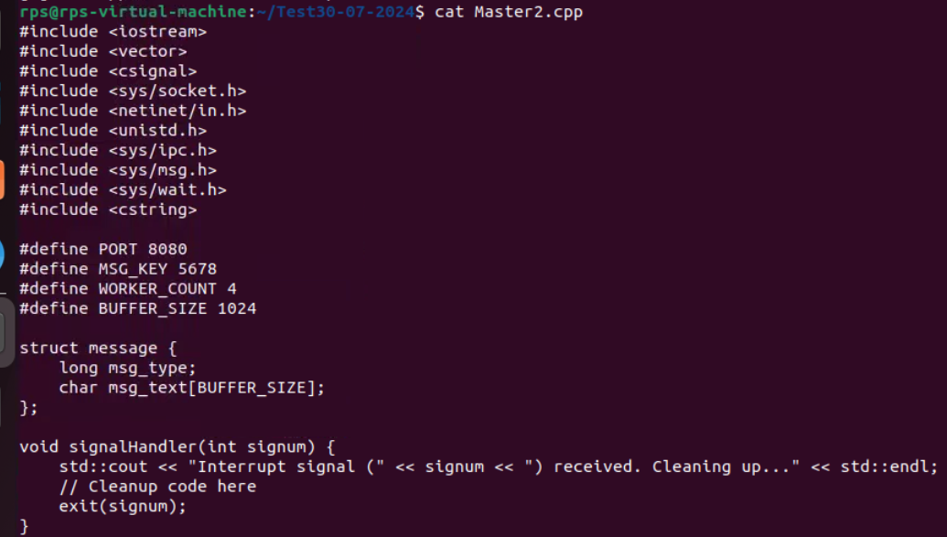

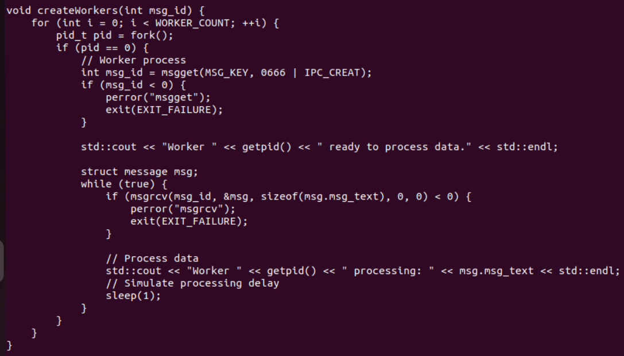

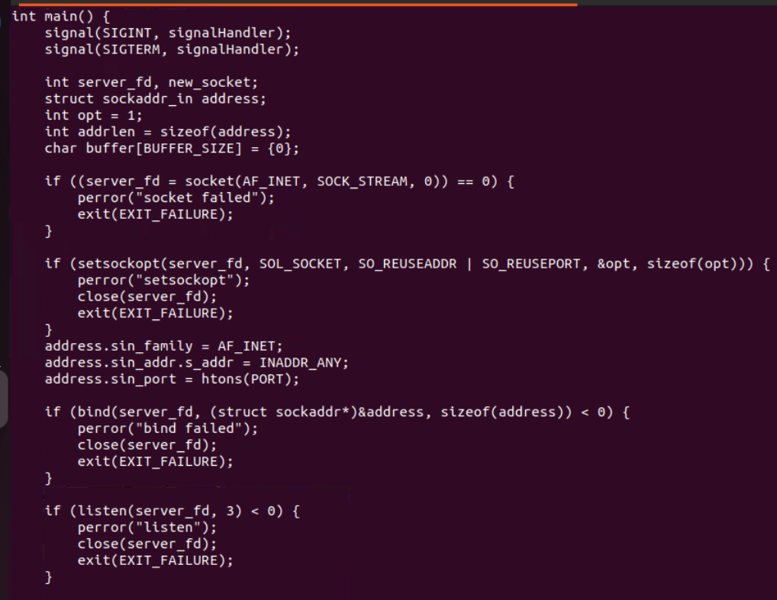

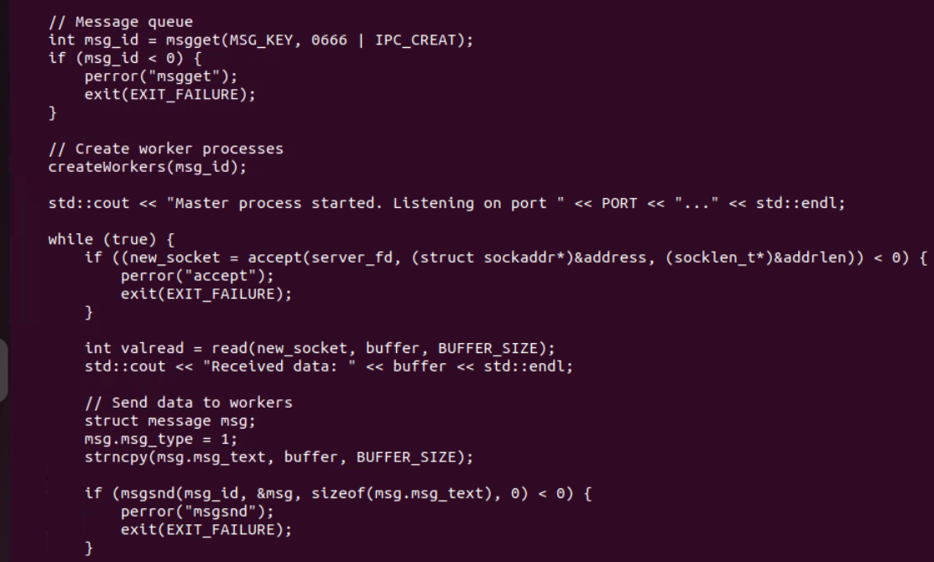

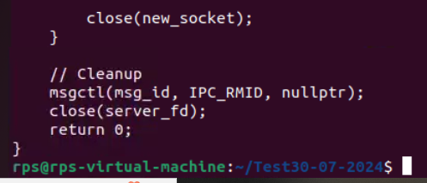

**CLIENT CODE:  
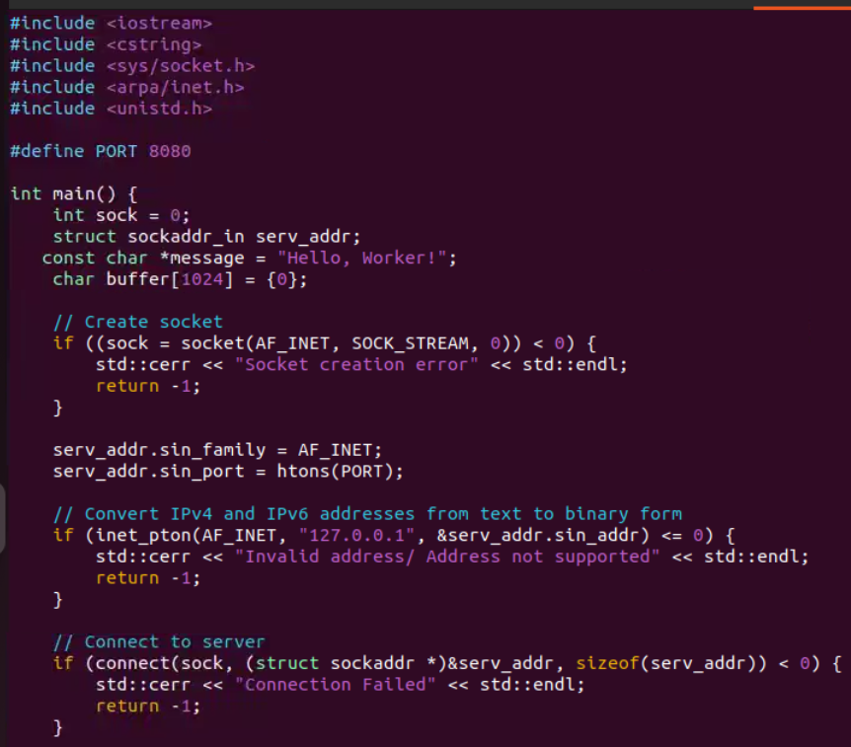**

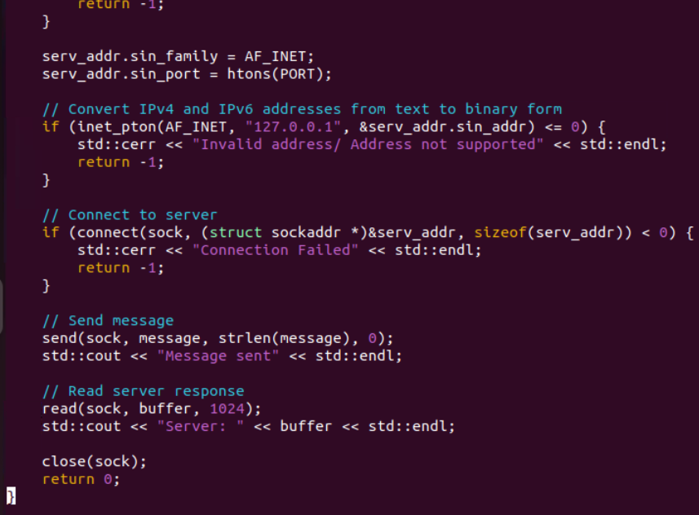

**OUTPUT:  
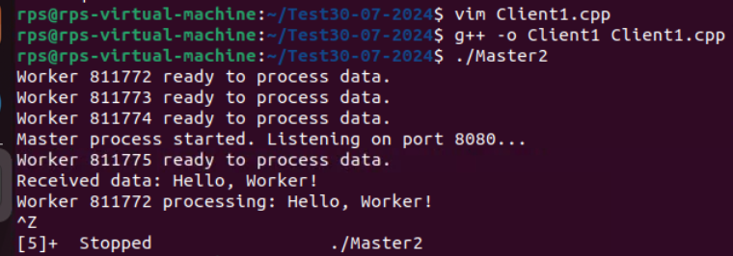**

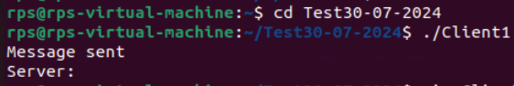

**TASK2:**

**Signal Handling:**

**Write a C++ program that sets up a signal handler for SIGINT. The program should perform some tasks and print a message when SIGINT is caught, then terminate gracefully.**

**How would you modify your program to handle multiple different signals, each with a unique handling function?**

**Single Signal Handling:**

**CODE:**

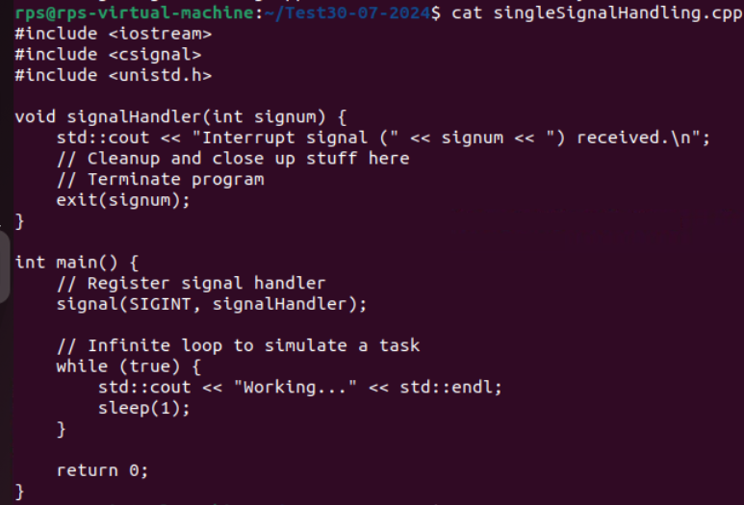

**Output:**

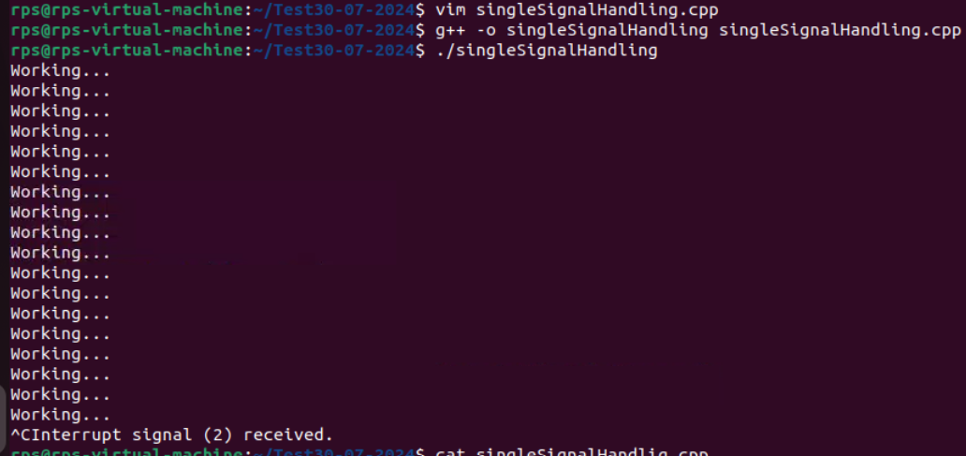

**MULTIPLE SIGNAL HANDLING:**

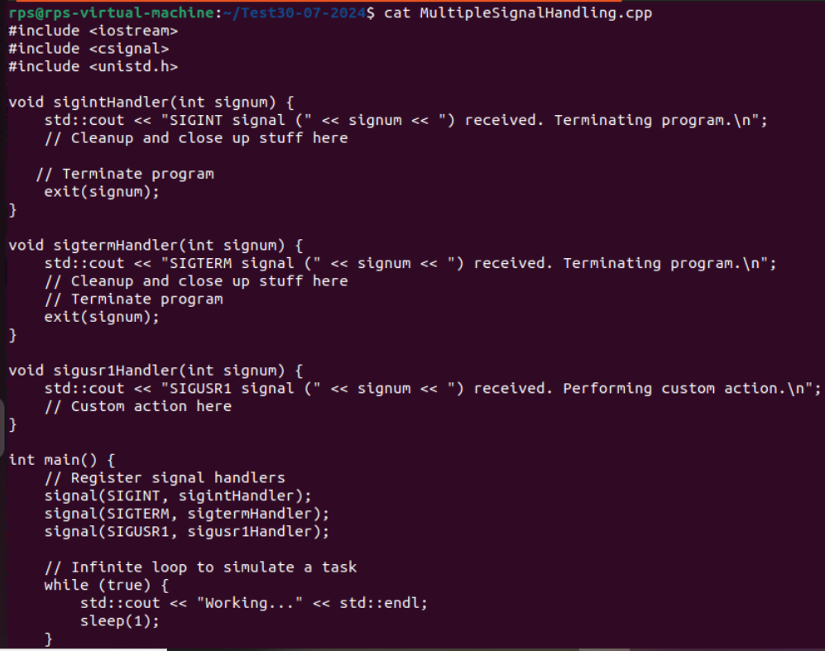

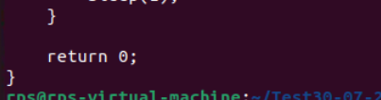

**OUTPUT:**

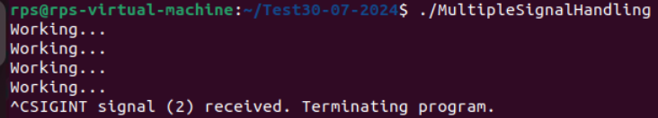

**TASK 3:**